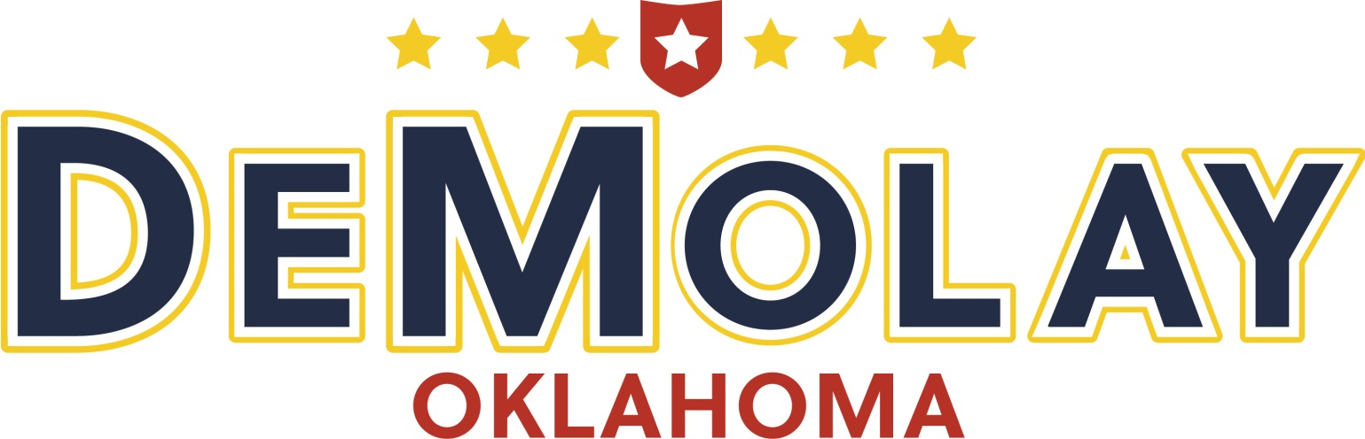

92st Oklahoma DeMolay Conclave
July 11 –14, 2019
NCED Conference Center & Hotel
2801 State Highway 9 East, Norman, OK 73071

This year’s conclave will be packed with activities such as:

Ritual Tournament
Election of New State Officers
Sweetheart Pageant
Sweetheart Ball
Scholarship Presentations
Chevalier Investiture
Legion of Honor Investiture
Cross of Honor Investiture
L.V. Orton Scholarship Interviews
Sports
Advisors Meeting
Mothers Club Meeting
Fellowship
Poolside Party
Swimming

- Conclave registration forms for Chapters are to be postmarked no later than 12:00 midnight, June 12, 2019 and must be sent to the Director of Conclave.

  - Registration Fee: $150.00 (Thurs/Fri/Sat/Sun) per person
  - Room Fee: $200.00 per room
  - Late Registration Fee: $25 additional charge per person
  - Cancellation Fee: $50.00 per Person

- The majority of personnel from each chapter must be pre-registered on the registration form.

- Late registration for people eligible to compete will be accepted up until midnight, July 1, 2019.

- The Chapter will receive $75.00 credit for each new member initiated between May 1 and July 10, 2019 who attends Conclave 2019.

- Large and Small Class Distinction for Conclave will be determined by the 2019 Chapter of the Year classes. Large Class Chapters (based on size and activities) will compete in the Large Class; Small Class Chapters will compete in the Small Class. Initiatory and DeMolay Degrees will have class distinctions only if 2 or more entries compete. Chapters may move up in class but may not move to the smaller class.

  - Ritual Contests will be based on the Frank Marshall Championship Tournament.

- The Exemplary Chapter at Conclave Award will be presented to a Chapter which excels in one or more of the following areas: Preparedness, Sportsmanship, Manners, Good Conduct, Participation, Neatness, Enthusiasm and Appearance. The winner is selected by an unannounced committee and the award may not be applied for. Your chapter can win by being on its best behavior. Last year's winner should bring the traveling trophy with them to Conclave.

- Remember to completely fill out room damage sheets provided by the hotel upon check-in. Damages occurring within rooms will be billed to the appropriate Chapters. Damages occurring in the hallways outside the rooms will be billed proportionally among those Chapters occupying that floor. Damages to elevators, lobbies, etc. will be billed proportionally among all Chapters in attendance. Vandalism to elevators and misuse of fire extinguishers are inexcusable, and will be dealt with accordingly. Squirt guns are not allowed in the hotel. Please leave them at home.

- The conclave registration desk for payment of fees and acceptance of packets will be open at 3:00 P.M. to 6:00 P.M. at the conference center before the ritual competitions Thursday evening. All chapters need to register during this time period.

- No DeMolay may register without an advisor present. Advisors must bring their medical release forms for each registrant and must be able to provide a copy should it be requested. In fact, just bring your entire insurance notebook.

- The Legion of Honor Investiture, Cross of Honor Ceremony, and Chevalier Investiture will be held on Saturday, July 13th at 6:00 pm.

- Each chapter should select/elect 4 delegates to represent the Chapter at Conclave in the business meetings of the Oklahoma DeMolay Association. A suggestion (not a requirement) is that the delegates be the three councilors and one at-large delegate. Please have a list of your Chapter’s delegates available for the caucus.

- Candidates for state offices may have no more than 2 campaign posters or banners confined to the convention center area. The signs are to be freestanding or attached by masking tape to glass, brick or tile surfaces (no painted surfaces.) Be advised that they may be asked to be removed by the hotel for any reason.

- All Chapters should be completely checked out of the hotel before the awards ceremony. As a reminder, this includes checking your Sweetheart out through Mom Bench.

- Chapter registration will be emailed directly to the Chapter Advisors.

CONCLAVE RULES

1. Curfew hours, unless revised by the State Advisors Association, will occur at the following times:
Thursday & Friday 12:00 A.M.
Saturday 1:00 A.M.

DeMolays should be in their rooms by the time of curfew. Remember that we are guests of the hotel and should conduct ourselves accordingly.

2. The use of all tobacco products is prohibited at the hotel and convention center. Advisors will strictly enforce the Oklahoma law which prohibits under age possession of tobacco and/or alcohol products.

3. Check your rooms immediately upon check-in and notify your Chapter Advisor of ANY damage to mattresses, window blinds, bathrooms, etc.

4. Windows in the hotel rooms are to be CLOSED at all times as open windows put a strain on the air conditioners and makes it harder for the building to be cool.

5. Your meal tickets are used to pay for your meals at the cafeteria. Do not lose these tickets, or you will have to buy more to use to eat at the cafeteria.

6. The room keys must be presented at time of check-out. Charges for each missing item will be collected at that time.

7. Please remember that we must present a positive image, especially to those who provide the housing and meal services, since how we act reflects directly back on our organization. Be sure that DeMolay has a positive image!

8. No females are to be in DeMolay rooms and no DeMolay are to be on the sweetheart floor or in a female advisor’s room.

CHECK-IN AND CHECK-OUT PROCEDURES

- Registration packets for DeMolays and Advisors will be given upon arrival of the Chapter Advisor or his/her designate. Packets of room keys for the blocked room assignments of the Chapter will be issued by the hotel desk to the Chapter Advisor or his/her designate. Floor diagrams for room assignments are to be returned to the Conclave Office by 11:00 p.m.

- Registration packets and room keys for Sweethearts and Chaperones will be given to those individuals by the Director of Sweethearts after checking in with her.

- Registration Packets for Parents, Advisors not housed with the DeMolays, State Officers, Ritual Judges, and other adults will be given upon their arrival at the Conclave desk. Their room key can be picked up at the Hotel desk.

- Check-out for DeMolays and the advisors housed on the DeMolay floors will start at 9:30 AM on Sunday. Advisors are to go to the hotel desk when ready to check-out and inform the personnel, and surrender the room keys. The hotel representative will follow you to your assigned rooms and inspect the rooms for damage and lock each room after being inspected. Chapters will then need to pay for damage. You may make arrangements with the hotel for storing luggage and miscellaneous items in one room, if needed.

- Check-out for Sweethearts (and removal of luggage) and Chaperones should be handled before the awards ceremony between 8:30 and 9:30 a.m. Room check-out for Sweethearts is under the direction of the Director of Sweethearts.

- Check-out for all registrants not housed on DeMolay or Sweetheart floors is at your discretion.

Should you have any questions, please contact:

Dad Ridge Smith
ODA, Director of Conclave
PO Box 851123
Yukon, OK 73085-1123

Cell: 405-990-8835
Email: director_conclave@okdemolay.com

